[](https://www.thedailymeal.com/11-secrets-supermarkets-dont-want-you-know)

[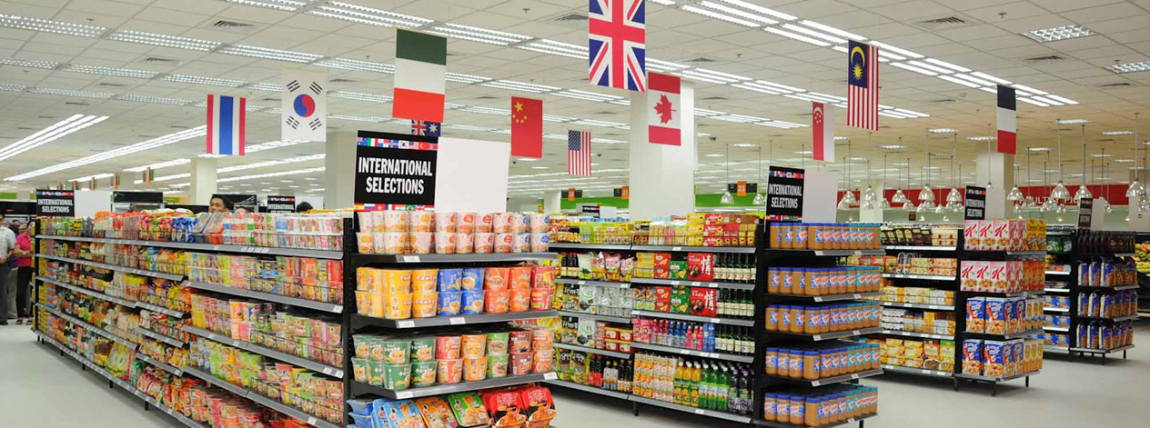](http://www.supermarket-doors.com/)

[](http://www.edp24.co.uk/features/i-wouldn-t-wear-my-bed-attire-in-public-for-fear-of-being-tasered-1-4840775)

